Employee Summary / Report
Path : Reports >> Employee Summary / Report.

Steps to reach Employee Summary / Report:
Step 1 : Reports in Steps to reach Employee Summary / Report : Open the Reports module from the Billing Application (POS).
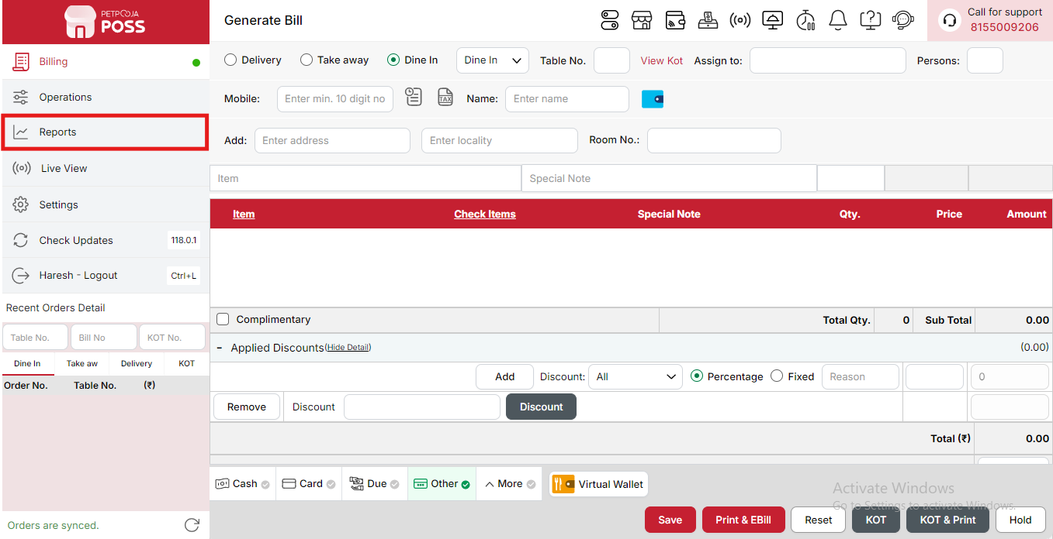
{Image Name: Reports Option,
Description: The red box highlights the “Reports” option in the sidebar menu. This section allows users to view and analyze various business reports, such as sales, billing, and order summaries, helping in effective tracking and decision-making. Here is an image of Step 1 Report in Steps to Reach Employee Summary / Report.}
Step 2 : Employee Summary / Report in Steps to reach Employee Summary / Report : Select Employee Summary / Report to view detailed performance and activity data of employees, including sales handled, shifts, and tips (if applicable).
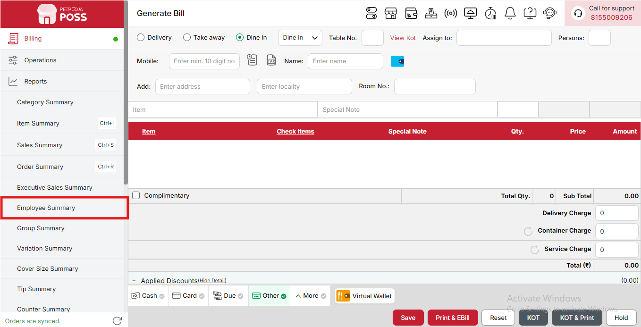
{Image Name: Employee Summary,
Description:The red box highlights the Employee Summary option in the Reports menu. This section provides detailed insights into employee activities and performance. It helps track sales handled by each employee, monitor work efficiency, and analyze overall staff contribution to business operations.Here is an image of Step 2 Employee Summary / Report in Steps to Reach Employee Summary / Report.}

Key features of Employee Summary / Report :
(Employee Summary / Report) Note: If you are not able to see or use the Employee Summary option in your billing application, it means that you do not have the required permission. To enable this, you need to go to the Owner Dashboard and open the User Management section. Inside User Management, you will find a permission called Employee Summary Show Button — you must checkmark this option to give access.If you are not able to view old day reports, then you also need to enable the Days Restriction permission. Inside the same User Management section, select No Restriction so that you can view reports for any date.After allowing these permissions, perform a manual sync so the system updates the rights properly. Once the sync is done, log out from the billing application and then log in again. After this process, the Employee Summary option will become visible, and you will be able to view all reports without any problem.

- (Employee Summary / Report) Orders Punched: Displays the total number of orders created or entered by the employee. This shows how many orders they have taken or billed during the selected period.
- (Employee Summary / Report) Orders Success: Shows the total number of successfully billed or completed orders handled by the employee, indicating their effective sales contribution.
- (Employee Summary / Report) Orders Cancelled: Indicates the total number of orders canceled by the employee. This helps track order handling errors or cancellations due to customer requests.
- (Employee Summary / Report) Orders Discounted: Displays the total number of orders where the employee applied discounts. It helps monitor the use of discounts and check if they were applied correctly.
- (Employee Summary / Report) Orders Modified: Shows how many orders were edited or updated by the employee after being created, such as changes in item quantity, price, or other order details.
- (Employee Summary / Report) Orders Reprinted: Indicates the total number of bills reprinted by the employee. This is useful for tracking when and how often reprints are made for verification or customer requests.
- (Employee Summary / Report) Cash: Represents the total cash amount collected by the employee for the orders they managed, ensuring clear tracking of physical payments.
- (Employee Summary / Report) Card: Displays the total value of payments received through card transactions processed by the employee.
- (Employee Summary / Report) Due Payment: Shows the total amount recorded as pending or unpaid in the employee’s transactions, useful for tracking incomplete payments.
- (Employee Summary / Report) Other: Represents the payments received through any other modes not categorized under cash, card, or online methods.
- (Employee Summary / Report) Wallet: Displays the total amount collected through digital wallet transactions such as Paytm Wallet or PhonePe Wallet.
- (Employee Summary / Report) Online Paid: Shows the total value of prepaid online orders received by the employee, where payment was made before the order was completed.
- (Employee Summary / Report) Online COD: Represents the total payment received for online orders where customers opted for Cash on Delivery (COD) mode.
- (Employee Summary / Report) Sub Total: Displays the combined total of all payment types handled by the employee, giving a complete overview of their total sales contribution.
- (Employee Summary / Report) Waiter/Delivery Boy: Displays the name of the waiter or delivery person responsible for managing or delivering the order. This helps identify who handled each transaction.
- (Employee Summary / Report) Invoice No.: Shows the unique invoice number assigned to every order, which helps in tracking and verifying specific bills linked to each waiter or delivery person.
- (Employee Summary / Report) Date: Indicates the date on which the order was processed, billed, or delivered. It helps in reviewing daily activities and payments on a specific date.
- (Employee Summary / Report) My Amount (₹): Represents the total sales amount generated by that particular waiter or delivery person before any deductions or additional charges.
- (Employee Summary / Report) Discount (₹): Displays the total discount applied on the order, either due to customer offers or manual adjustments by staff.
- (Employee Summary / Report) Delivery Charge (₹): Shows the delivery fee added to the order, if applicable, for home delivery or special services.
- (Employee Summary / Report) Total (₹): Represents the final order amount after applying discounts and adding delivery charges. It shows the actual billed total for that transaction.
- (Employee Summary / Report) Collected Price (₹): Displays the actual amount received from the customer by the waiter or delivery person, helping ensure proper cash handling and settlement.
- (Employee Summary / Report) Amount Taken: Indicates whether the waiter or delivery person has already handed over or still holds the collected amount. This helps maintain accountability and prevent cash discrepancies.
- (Employee Summary / Report) Sub Total: Displays the combined total of all records listed for each waiter or delivery person, providing a complete overview of their sales and collections during the selected period.
Search Button (Employee Summary / Report) : The Search button is used to find the report for a specific date or time. It helps you quickly see sales details for the selected period. After choosing the date or time, you can click on Search to view the report.
- From (Employee Summary) : The From option is used to select the starting date for the employee report. It means the report will begin from this date.
- To (Employee Summary) : The To option is used to select the ending date for the employee report. It means the report will show data up to this date.
- Employee (Employee Summary) : The Employee option allows you to select the employee for whom you want to view the report. After selecting the employee, you can see the detailed report for that specific person within the selected date range.
- Time Wise Option (Employee Summary) : The Time Wise Option is used when you want to see the report for a specific time period within a day. After turning it ON, you can choose both date and time — for example, from 10:00 AM to 5:00 PM — to see sales during that time. If you keep this option OFF (Without Time Wise Option), then the report will show the whole day’s data for the selected date range without filtering by time.
(Employee Summary) Configure Column: Used to show or hide different columns in the report by checking or unchecking the boxes. If you want to see that option in the report, you have to check it, and if you want to hide it, you have to uncheck it.
- (Configure Column) Invoice No.: Shows the invoice number for each transaction handled by the employee. You can check this to display it in the report or uncheck it to hide it.
- (Configure Column) Date: Shows the date on which the transaction occurred. You can check this to view it in the report or uncheck it to hide it.
- (Configure Column) My Amount (₹): Shows the total amount before applying any discounts or delivery charges. You can check this to display it in the report or uncheck it to hide it.
- (Configure Column) Discount (₹): Shows the total discount given on the order. You can check this to show discount details or uncheck it to hide them.
- (Configure Column) Delivery Charge (₹): Shows the delivery charge applied to the order. You can check this to display delivery details or uncheck it to hide them.
- (Configure Column) Total (₹): Shows the total payable amount after applying discounts and adding delivery charges. You can check this to view it in the report or uncheck it to hide it.
- (Configure Column) Collected Price (₹): Shows the amount collected from the customer for the transaction. You can check this to display it in the report or uncheck it to hide it.
- (Configure Column) Amount Taken: Shows the total amount received by the employee for the sales handled. You can check this to view it in the report or uncheck it to hide it.

(Employee Summary / Report) Print Button: The Print Button is used to print the report. If you want to take a printout of the report, you just need to click on the Print button.
If you get an error saying “Please assign one printer for report print”, then follow these steps:
- Go to Operation → Bill/KOT Print → Multiple Printer Settings.
- Select and edit one printer that you want to use for printing the report.
- In that printer setting, there is an option called “Use this printer for report print”.
- Check this box and save the setting.
After doing this, you will be able to print the report successfully using the selected printer.
(Employee Summary) Print Configuration: This section is used to set how your report will look when you print it. You can change the format, size, and what details to show on the printed page.
- (Print Configuration) Show Bill Header: If you check this option, the header (top part with company or shop name) will appear on the print.
- (Print Configuration) Show Bill Footer: If you check this option, the footer (bottom part with notes or messages) will appear on the printed report.
- (Print Configuration) NONE: Select this option if you don’t want to apply any specific print format or layout. The report will print in the default basic format without additional formatting or sections.
- (Print Configuration) Display To Date on Print: If you check this option, the “To Date” of the report will be shown on the printed page.
- (Print Configuration) Display Time on Print: If you check this option, the time will be displayed on the print along with the date.
- (Print Configuration) Display Summary Box on Print: If you check this option, a summary box will appear at the end of the report showing total amounts and other summary details.
- (Print Configuration) Display Print Date & Time on Print: If you check this option, the date and time when the report was printed will appear on the print.
- (Print Configuration) Main Width: Used to set the width of the report on the printed page. For example, 500 means the report will be printed with that width size.
- (Print Configuration) Font Size: Used to set the text size of the printed report. You can increase or decrease it as needed.
- (Print Configuration) Cancel: Click this button to close the print configuration window without saving any changes.
- (Print Configuration) Save:Click this button to save all the changes you made in the print configuration settings.
(Employee Summary) Export Excel: If you want to download or save the report in Excel format, you have to click on the Export Excel button. This will create an Excel file of the report that you can open and use in Microsoft Excel.

